Computer Language Coding Concepts

Creation Behavior of ‘Inactive Calls’ in a Diagram
The article Creation Behavior of ‘Inactive Calls’ already explained this behavior conceptually. The current article further clarifies the idea using diagrams.

Command calls inside a parent command have special creation behavior:

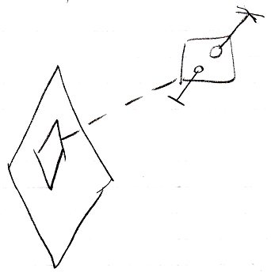

Their publics are created as soon as the parent command is created

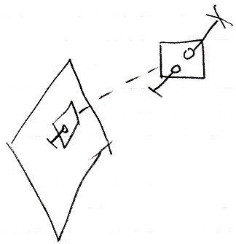

but their privates are only created when the command call is about to be run.

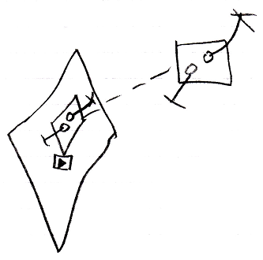

Special creation behavior does not count for inactive command objects inside a parent command, that have a class redirection to a command definition.

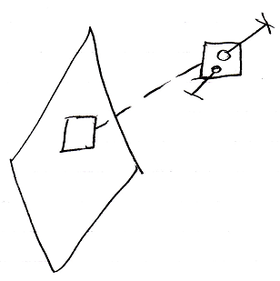

This looks like the inactive form of a command call, but this kind of object does not have special creation behavior like that. It is an uncommon situation. But an inactive command inside a parent command with a class reference to a definition can be referenced

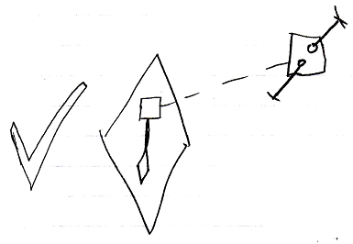

Unlike its active form, which can not be referenced.

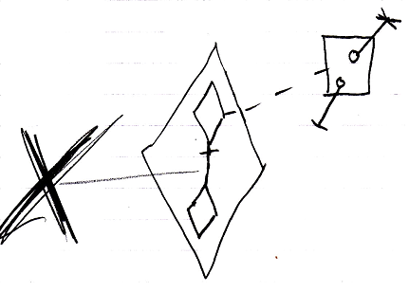

Therefore, it can also be class referenced by a call.

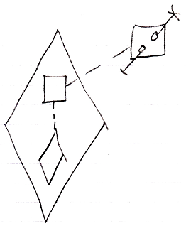

In that case its privates and publics had better be there more permantly, or the call to it can not instantiate private contents at all.

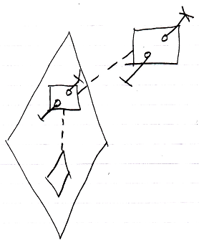

Creating its private contents, does not create a recursive creation or anything: the inactive call’s own private calls do not create their private contents, so there is no recursion there.

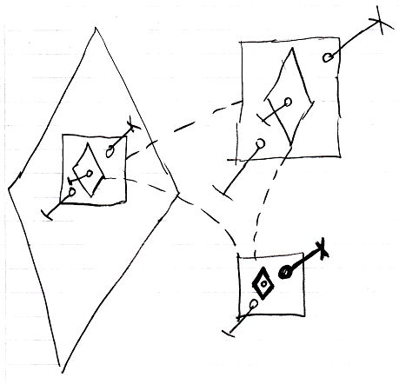

See also: Creation Behavior of Calls, Commands

Author & Copyright: Jan-Joost van Zon Date: August 28, 2008 – August 28, 2008 Location: Oosterhout, The Netherlands Status: Finished

